Tuples:

(8888,990,”gayu”,90)

Immutable

(90)>>>int

(85,)>>>tuple

type()>>>>>

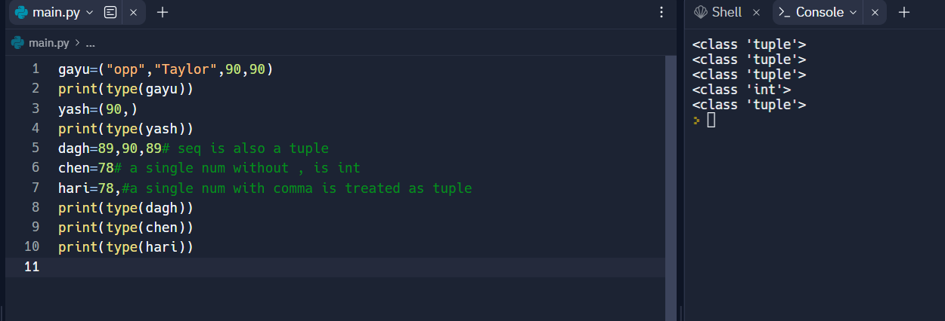

Accessing Elements in a Tuple:

Tuple can also be accessed using indexing, it behaves same as list..operators,expression..

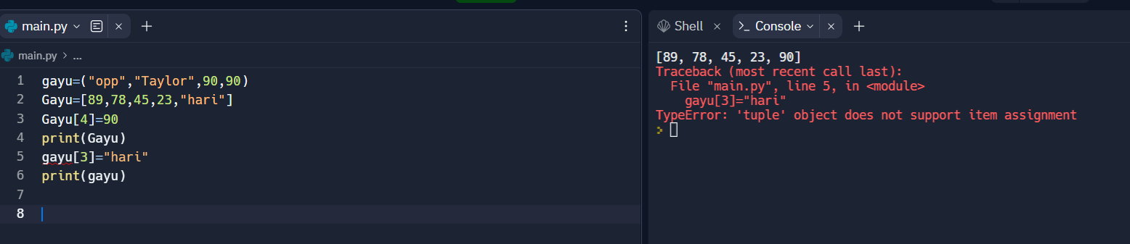

Even a tuple can be mutable if it has list inside.

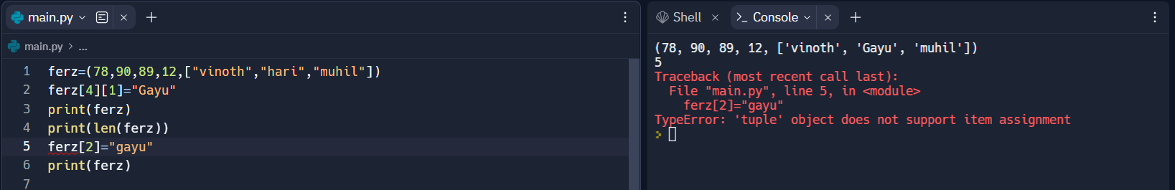

Tuple(operations):

Concatenation:

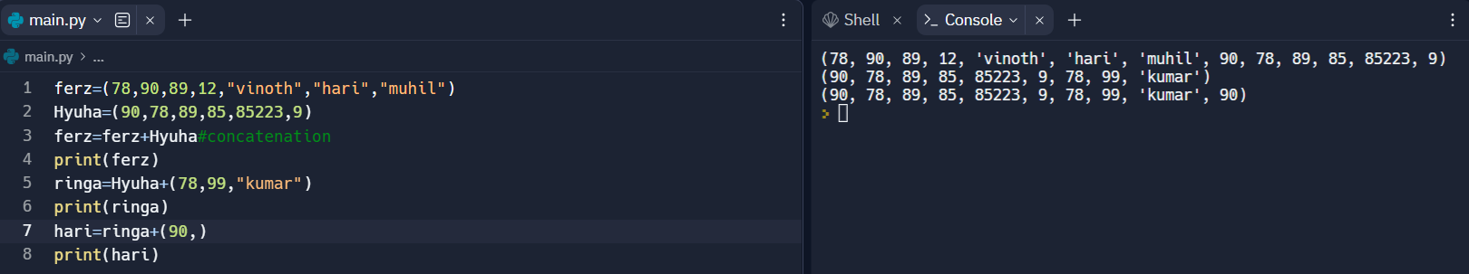

Repetition,membership,slicing:

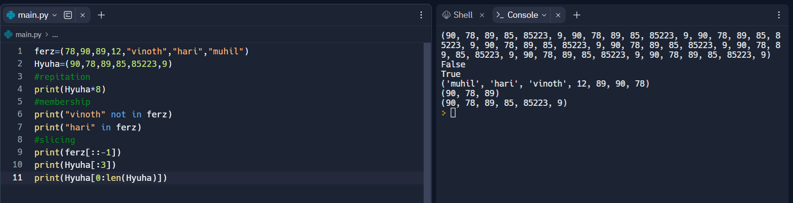

INBUILD FUNCTION:



Tuple Assignment:

